Ceng 435 – WireShark Assignment 3

Muhammed Yusuf Temizer - e2099356

Answer 1:

 | Attacker | Victim | User | OVS
IP Numbers | 10.10.2.1 | 10.10.1.1 | 10.10.3.2 | 10.10.3.1

Answer 2:

ICMP packets have no source and destination port numbers since they are created to communicate network-layer information between hosts and routers. It’s aim is not to communicate between application layer processes. ICMP packets include “Type” and “Code” data. They identifies the specific message being received. Port numbers are not necessary to direct the the ICMP message to an another application layer process because network software itself interprets ICMP messages.

Answer 3:

 | Request Packet Sequence | Reply Packet Sequence
1. | 11 | 12
2. | 15 | 16
3. | 19 | 20
4. | 23 | 24
5. | 27 | 28

Answer 4:

 | Type No | Code No | Checksum Byte | Sequence Number Byte | ID Field Byte
1. | 8 | 0 | 2 | 4 | 4
2. | 8 | 0 | 2 | 4 | 4
3. | 8 | 0 | 2 | 4 | 4
4. | 8 | 0 | 2 | 4 | 4
5. | 8 | 0 | 2 | 4 | 4

Answer 5:
All of the source-destination pair TTL value are the same which is 63-64 (source-destination).

Answer 6:

Resources:

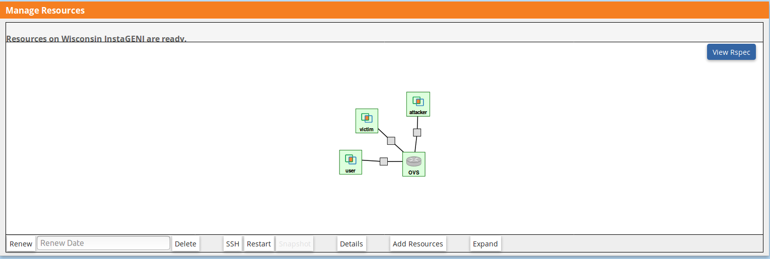
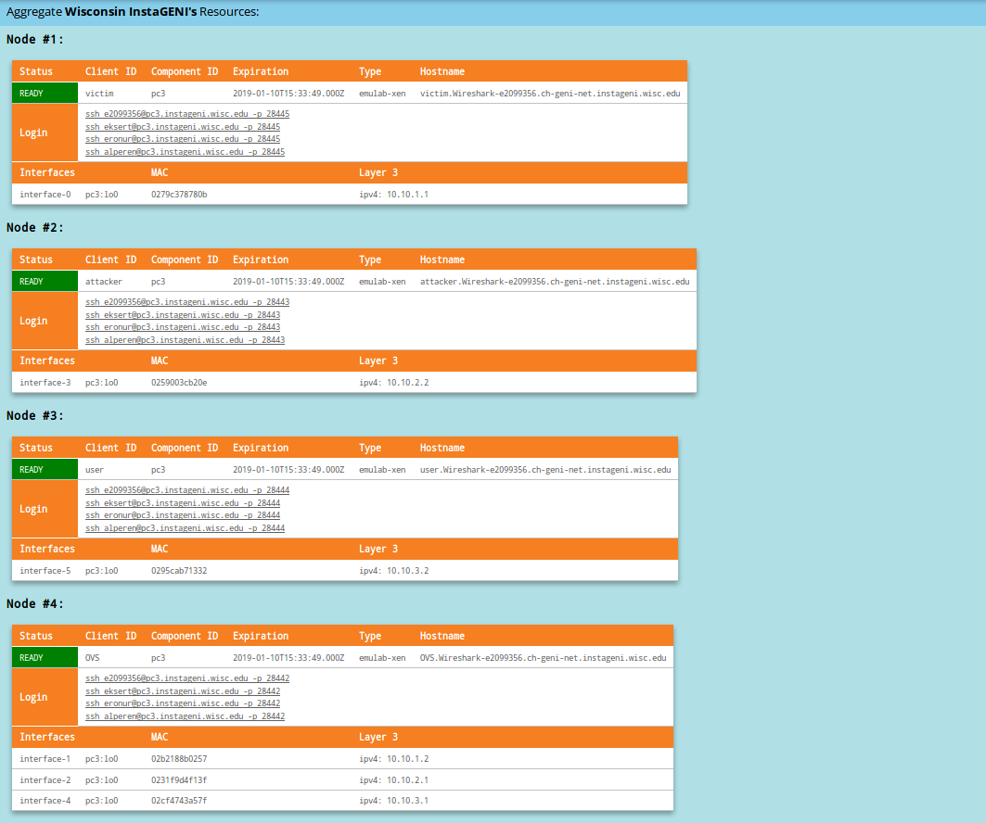
Details:

